**BANK LOAN REPORT QUERY DOCUMENT**

1. **BANK LOAN REPORT | SUMMARY**

**KPI’s:**

**Total Loan Applications:**

select count(id) Total_Loan_Applications from financial_loan



**MTD Total Loan Applications:**

select count(id) MTD_Total_Loan_Applications from financial_loan

where month(issue_date) = 12



**PMTD Total Loan Applications:**

select count(id) PMTD_Total_Loan_Applications from financial_loan

where month(issue_date) = 11



**Total Funded Amount:**

select sum(loan_amount) Total_Funded_Amount from financial_loan



**MTD Total Funded Amount:**

select sum(loan_amount) MTD_Total_Funded_Amount from financial_loan

where month(issue_date) = 12



**PMTD Total Funded Amount:**

select sum(loan_amount) PMTD_Total_Funded_Amount from financial_loan

where month(issue_date) = 11



**Total Amount Received**

SELECT SUM(total_payment) AS Total_Amount_Collected FROM financial_loan



**MTD Total Amount Received**

SELECT SUM(total_payment) AS MTD_Total_Amount_Collected FROM financial_loan

WHERE MONTH(issue_date) = 12



**PMTD Total Amount Received**

SELECT SUM(total_payment) AS PMTD_Total_Amount_Collected FROM financial_loan

WHERE MONTH(issue_date) = 11



**Average Interest Rate**

select avg(int_rate)*100 as Avg_Interest_Rate from financial_loan



**MTD Average Interest Rate**

select avg(int_rate)*100 as MTD_Avg_Interest_Rate from financial_loan

where month(issue_date) = 12



**PMTD Average Interest Rate**

select avg(int_rate)*100 as PMTD_Avg_Interest_Rate from financial_loan

where month(issue_date) = 11



**AVG DTI**

select avg(dti)*100 Avg_DTI from financial_loan



**MTD AVG DTI**

select avg(dti)*100 MTD_Avg_DTI from financial_loan

where month(issue_date) = 12



**PMTD AVG DTI**

select avg(dti)*100 PMTD_Avg_DTI from financial_loan

where month(issue_date) = 11



**Good Loan Issues:**

**Good Loan Percentage**

select cast(count(id)*100.0/(select count(*) from financial_loan) as decimal(10,2)) as Good_Loan_Percentage

from financial_loan

where loan_status = 'Fully Paid' or loan_status ='Current'



**Good Loan Application**

select count(*) Good_Loan_Application

from financial_loan

where loan_status = 'Fully Paid' or loan_status ='Current'



**Good Loan Funded Amount**

select sum(loan_amount) Good_Loan_Funded_Amount

from financial_loan

where loan_status = 'Fully Paid' or loan_status ='Current'



**Good Loan Total Received Amount**

select sum(total_payment) Good_Loan_Total_Received_Amount

from financial_loan

where loan_status = 'Fully Paid' or loan_status ='Current'



**Bad Loan Issues:**

**Bad Loan Percentage**

select cast(count(id)*100.0/(select count(*) from financial_loan) as decimal(10,2)) as Bad_Loan_Percentage

from financial_loan

where loan_status = 'Charged Off'



**Bad Loan Application**

select count(*) Bad_Loan_Application

from financial_loan

where loan_status = 'Charged Off'



**Bad Loan Funded Amount**

select sum(loan_amount) Bad_Loan_Funded_Amount

from financial_loan  
where loan_status = 'Charged Off'



**Bad Loan Total Received Amount**

select sum(total_payment) Bad_Loan_Total_Received_Amount

from financial_loan  
where loan_status = 'Charged Off'



**Loan Status**

SELECT

loan_status,

COUNT(id) AS LoanCount,

SUM(total_payment) AS Total_Amount_Received,

SUM(loan_amount) AS Total_Funded_Amount,

AVG(int_rate * 100) AS Interest_Rate,

AVG(dti * 100) AS DTI

FROM bank_loan_data

GROUP BY loan_status

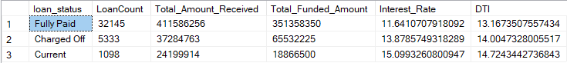

select loan_status,

sum(loan_amount) Total_Funded_Amount,

sum(total_payment) Total_Amount_Received

from financial_loan

where month(issue_date) = 12

group by loan_status

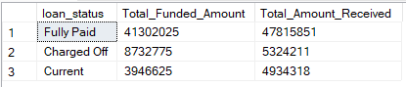

1. **BANK LOAN REPORT | OVERVIEW**

**Month**

select month(issue_date) as Months,

datename(m,issue_date) as Month_name,

count(id) Total_Loan_Application,

sum(loan_amount) Total_Funded_Amount,

sum(total_payment) Total_Amount_Received

from financial_loan

group by month(issue_date), datename(m,issue_date)

order by Months

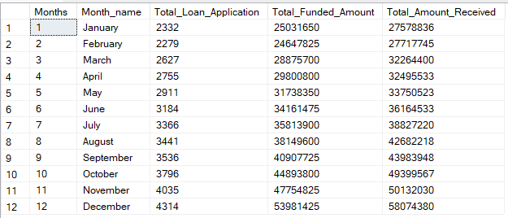

**State**

select address_state State,

count(id) Total_Loan_Application,

sum(loan_amount) Total_Funded_Amount,

sum(total_payment) Total_Amount_Received

from financial_loan

group by address_state

order by address_state

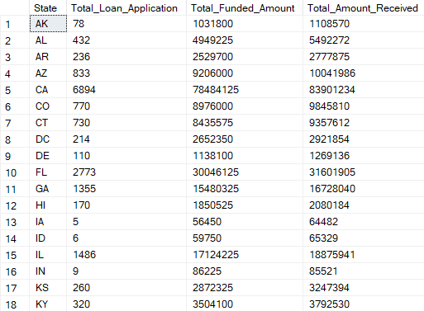

**Term**

select term Term,

count(id) Total_Loan_Application,

sum(loan_amount) Total_Funded_Amount,

sum(total_payment) Total_Amount_Received

from financial_loan

group by term

order by term



**Employee Length**

select emp_length Employee_Length,

count(id) Total_Loan_Application,

sum(loan_amount) Total_Funded_Amount,

sum(total_payment) Total_Amount_Received

from financial_loan

group by emp_length

order by emp_length

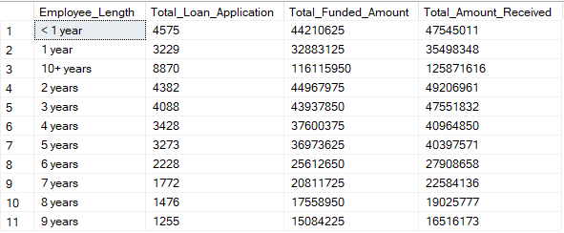

**Purpose**

select purpose Purpose,

count(id) Total_Loan_Application,

sum(loan_amount) Total_Funded_Amount,

sum(total_payment) Total_Amount_Received

from financial_loan

group by purpose

order by count(id) desc

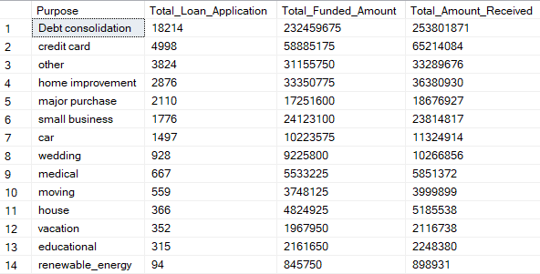

**Home Ownership**

select home_ownership Home_Ownership,

count(id) Total_Loan_Application,

sum(loan_amount) Total_Funded_Amount,

sum(total_payment) Total_Amount_Received

from financial_loan

group by home_ownership

order by count(id) desc

